Draft minutes of the meeting of Islip Parish Council held on Tuesday 27th September 2022 at 7.15pm at the Village Hall, Islip

Present- Cllrs E Taylor (Chair) E Curbishley, B Hughes, R Horrell, R Maxwell, R Tarling-Toley
NNCllr. W Brackenbury Clerk-C Tilley

22/59 | APOLOGIES FOR ABSENCE- received and approved for Cllrs Harris and Duval. Apologies also received from NNCllrs D Brackenbury and G Shacklock. Cllr Maxwell to leave early- SF item moved to beginning of meeting
22/60 | PUBLIC PARTICIPATION- None Present
22/61 | DECLARATION OF INTERESTS
 | To receive all declarations of interest under the Council’s Code of Conduct related to business on the agenda. (Members should disclose any interests in the business to be discussed and are reminded that the disclosure of a Disclosable Pecuniary Interest will require that the member withdraws from the meeting room during the transaction of that item of business). None declared
22/62 | MINUTES OF THE LAST MEETING-circulated
 | Resolved to confirm as correct the record of the minutes of the meeting held on Tuesday 21st June 2022 and of the Extra-ordinary meeting 17th August 2022. Chairman signed
22/63 | GOVERNANCE-
a) Cllr Horrell reported all in order with Internal Control and Cllr Tarling-Toley volunteered for December, Cllr Hughes for March
b) Register of Interests- Cllrs Duval and Harris to add home address, Cllr Curbishley to submit one
c) Reviewed and reapproved Risk Assessment
d) Reviewed and reapproved Asset register-some items removed/added
e) Confirmed that Insurance policy is still sufficient and to approve payment and continuance of long -term agreement (up to Sept 2023). Decided against index linking policy, to avoid with a premium increase in what should be a fixed term price. (Appendix 1)
f) To note that the Conclusion of External audit had been received, with no observations and that the Notice of conclusion of audit is to be published alongside the Annual Return
g) Resolved to stay with the SAAA for external audit purposes
22/64 | PLANNING APPLICATIONS- to discuss and comment where necessary
None at production of Agenda
To note- Permission GRANTED for NE/22/00032/FUL- 13 Kettering Rd- Erection of one dwelling and NE/22/00872/FUL- 8 Rushmere Cl-single storey extensions.
To note that North Northants Planning has been sending some planning consultations to the incorrect email address. Clerk has made a complaint. Applications known to be affected NE/22/00750/FUL 10 Mill Rd- Granted NE/22/00726/FUL 5 High St-Refused
22/65 | NORTH NORTHANTS COUNCILLORS’ REPORTS- For Information Only
 | Executive agreed to harmonise waste subscription so as of April next year all residents wanting green waste removal will be charged £40 pa. Anyone in the old ENDC area who renewed their subscription from 1st December will be charged the new rate, and will get a rebate for 12months. NNC will also provide subsidised compost bins. New Highways 7yr contract made with Kier who were the cheapest and best on quality sarah.barnwell@northnorthants.gov.uk is still the Highway Liaison officer. There will also be 1.5 million for parish improvements.
22/66 | FINANCE
- Received and approve the Financial Reports for August & Payments made and due for September 2022 (Attached)
- Received quarterly budget monitoring document (Attached) No issues highlighted. A 1/3rd of budget has been spent since April so on track at present
- Approved a budget amount of £100 for the Quiz night and approve signage ordered.
- Noted that underpaid VAT will be added to next quarters return and paid from Sports Field account
22/67 | HIGHWAYS AND FOOTPATHS-
- No relevant updates from Cllr Taylor
- Noted that Tree works have been completed along Chapel Hill and council generally very impressed with the works carried out. An empty sign post has been uncovered that was probably a sharp bend sign. ACTION- Clerk to query with Highways.
- High St faded sign reported
22/68 | RECREATION GROUND- Receive checks from councillors – all in order
- Remedial works document –(circulated) Cllr Hughes will double check what has been done and what still needs doing. Quotes for surfacing and cable wire repairs. Agreed to go with Company 2, as long as the quote includes all surfacing. ACTION Clerk to double check
- Litter bins- the liners are rusted through- ACTION- Clerk to get quotes for 3 new more visible/child appropriate ones
22/69 | SPORTS FIELD-
- RM reported- generally going well. Cricket season finished.
- SSE situation update- have accepted correct reading. Account in credit. Ombudsman decision date due 3rd October.
- Date for next Sports Committee meeting –ACTION-Cllr Maxwell will set a date in October. After Revised User agreement with VAT clarification on discussed. Confirmed that Block bookings (10+) have to be invoiced in advance to qualify for VAT exemption. Occasional users of field and pavilion payment in advance. VAT on all pavilion users charged monthly in arrears. Cllr Maxwell authorised letter of explanation and new User agreement to be sent out to all users on behalf of IPC/SFC.
- Booking calendar- move to live document. ACTION- Cllr Maxwell put advert on ‘fivr’ but no response. Suggestion of ‘Upwork’- RM will continue to look into
22/70 | COMMUNITY MATTERS-
- Lowick Road planter- update on sculpture. A 3D design was deemed not suitable. Cllr Lymn will do some further research.
- Organised volunteers to plant bulbs along Kettering Road at 10.00am 9th October meet at bench corner of Kettering Rd, Toll Bar Rd. Suggested purchasing bulb planters. Agreed to purchase 2 up to a maximum of £100. ACTION-Clerk to check with Emery if any more grass cuts are due.
- High St Information Board- Draft content discussed. Some amendment and additions needed. ACTION- Cllr Horrell will speak to Historian in person.
- Annual quiz -in conjunction with the Rotary Club. October 15th Cllr Lymn updated. Raffle organised by the Rotary Club. Very good prizes- encourage all to buy tickets. Over half the quiz tickets have been sold.
- Neighbourhood Watch. The Clerk has inadvertently been put down as the village co-ordinator. Clerk unsuitable as doesn’t live in the village- will be advertised in the newsletter and FB
- Discussed possibility of installing a ‘Bleed cabinet’ in the village. Off the Streets NN organisation have been installing them across the county. (Appendix 3). Decided in principal it is a good idea. Defer to next meeting to think about a suitable site whether it is linked with ambulance service. ACTION-Clerk to research
- Cllr Hughes presented some ideas for Community Engagement. Newsletter item- basic overview of the council. What they do etc. Surveys- what are concerns. ACTION- Cllr Hughes will draw up something to go in the newsletter.
22/71 | CLERK UPDATES AND CORRESPONDENCE- To action where necessary
- Yu energy- have now passed account for investigation-and have determined that consumption has dropped so bills are correct
- Paypal- to note that Clerk has closed this account as was not useable.
- Stagecoach is running new bus service for Kettering-Geddington-Corby route- to include Islip. Timetable on website
- Clerk provided a brief summary of Finance Summit that she attended.
22/72 | OPPORTUNITY TO UPDATE COLLEAGUES- For information only- no decisions to be made  War Memorial plaque in church needs restoring- a restorer is going to assess the works. Would be £350 per day.
22/73 | DATE FOR NEXT MEETING- 18th October Any items for Agenda to be sent to Clerk 7 days before meeting  Memorial Wreath. Christmas community engagement budget VAS sign- Chapel Hill

Appendix 1
Council entered into a long term (3yr) agreement with Ecclesiastical. This was done on understanding that premium remains the same at £2465.17. However, quote received was £2,740.24. The insurers say “The premium under a long- term agreement is protected from any market increases, we do however still index link the sums insured to keep them relevant in line with inflation hence the slight uplift”

Appendix 2 Quotes for servicing of Zip Wire and replacement of rubber surfacing
Company 1 Cableway service £655 Renew all surfacing £7322.50
Company 2 Original Provider- Cableway Service & resurfacing £2,277.20 & VAT
Company 3 Carpet surfacing £4,347.83 (can’t do cable repairs)

Appendix 3 Bleed cabinets- designed to stop major bleed whilst waiting for emergency services
Cheapest available- Defib world https://defibworld.org/bleed-control-kit
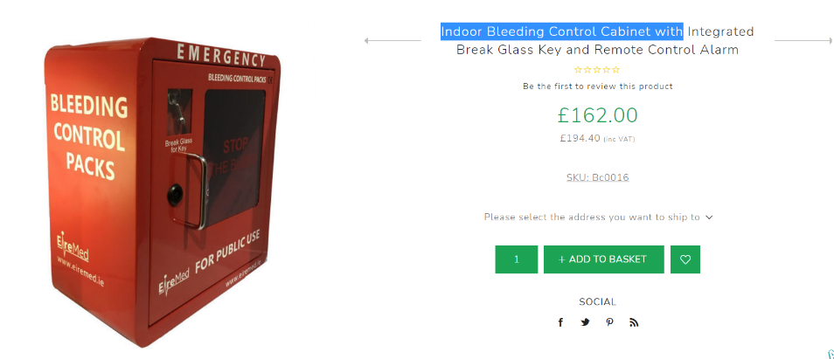
£160 & VAT for kit £162 &VAT or £350 & VAT locked or unlocked cabinet

