Sports Field Committee
Chairman Richard Maxwell (IPC) Edd Curbishley (IPC) Emma Taylor (Chairman IPC) Finance Richard / Claire Fixtures Richard Pavilion Dorothy Maxwell
Head Groundsmen Football Richard / Howard Projects Richard
Head Groundsman Cricket Les TCC Clerk- Claire
Minutes for Sports Field Committee meeting- held Wednesday 29th June, 7.30pm at Islip Sports Pavilion

Present
R Maxwell, (IPC) E Taylor (IPC), D Maxwell (SFC) D Williams (Islip Cricket Club)
H Willmott (Northampton Lions) C Burdett, J Burdett (Thrapston Cricket Club) Gary Tomsett, Mike Early (R&D Junior FC) Clerk C Tilley

Previous minutes -August 2021 approved

1. Matters Raised
a. Volunteers = HUGE Thank You to all volunteers who continue to put many hours in.
• Pavilion – Dorothy
• Cricket square – Les & Andy
• Football pitches – Richard & Howard
• Finances & Funding – Richard
• Fixtures & Admin – Richard
b. Finances RM/CT

Current actual bank balance £11,333 at end of June - with a £962.00 VAT refund due

Budget -RM presented an overview of the finances over the last ten years, showing the SFC is now self-funding, and a breakdown of contribution to income by various user groups for 2021-22.

45% Pavilion
36% Football (Adults and Juniors)
12% Other field users
4% Cricket
3% Parties

This gives an average of £20K income a year. A budget was presented for discussion which was very similar to previous year, although electricity prices have increased, ground renovation decreased and pavilion maintenance and cleaning increased due to inflation. £2000 was allocated to Property improvements as fascia and guttering still need works

Additional items to be considered for budget- one flood light is out. Offers of scaffold tower to assist in replacement. (Lamp needs purchasing c £140 each)
Decided to keep reserves of £2000.
c. General
Booking software- the Clerk presented various options to solve the issue of a static booking calendar. (attached) Many are quite expensive and more geared towards multiple one off bookings rather than block bookings, which is how the field and pavilion are currently utilised. Decided to go with trying to make the Database a live document. GT will speak to his wife who is in IT. Otherwise RM will look to source an IT person.

d. Cricket

DW- commented on undulating surface of cricket outfield and safety concerns of ball rebound, although he appreciated it is difficult tomaintan the standard of this. RM explained how they are allowing the grass to grow slightly to preserve the surface that has been very worn over the years. A general discussion was had regarding reparation of pitches. User groups will work together to ensure the rpgoramm of renovation is fair to all.

e. Pavilion
DM- please can all users hoover through and clean up after themselves. Leave it as you would expect to find it.
f. Football
GT would like more floodlights to be able to utilise more of the field.
ME spoke for Mike Swindell who would appreciate more storage, preferential hirer rates for user groups. Are there any other opportunities for different groups through summer and school holidays.

Other matters for information only

JB -pile of fallen wood behind sight screens. They are happy to move them. Decided they can be moved towards the fence prior to final removal.

RM- hopefully Gigaclear will install an internet line to the Sports Pavilion in late summer.

Meeting closed at 20.50pm Next meeting date to be determined

2. User Overview -may need further revision
a. Cricket
- Thrapston Town Cricket Club 3rds (Sat Div12)
- Thrapston Town Cricket Club 4ths (Sat Div14)
- Islip Cricket Club (Sunday)
b. Football
- Diamonds CIC Juniors U8s (Weetabix)
- Diamonds CIC Juniors U11s (Weetabix)
- Diamonds Academy U21s (Midland Football League)
- Diamonds CIC Walking Football- summer only
- Kettering FC Juniors U12s (Weetabix – train only)
- Northampton Lions U18s (Midland Junior Premier League)
- Northamptonshire Girls Goalkeeping Advance Player Development Centre (NFA – train only)
- Sargents FC (Nene Sunday League)
- Sargents FC (Bedford Sunday League)
    - Richard Scott-shot stoppers
- Islip Rounders Club

Pavilion
Art Class
- Fitness Bootcamps
- Yoga
- Zumba
- Allegra Singers

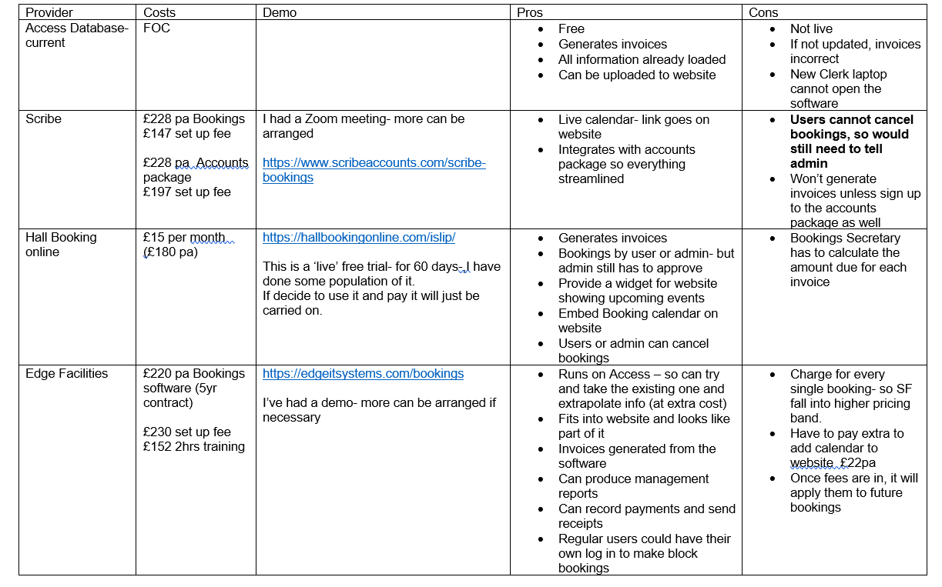
Notes:
Rationale behind looking at new options-
- The calendar is not live- user groups have to check with RM/DM as to whether bookings can be made.
- Last minute bookings/cancellations probably not reflected in calendar.
- Party bookings difficult to administer if no contact details appear on calendar.

Findings
- All the paid for booking options seem set up for user groups to make their own bookings, rather than admin inputting block bookings
- All details including hire times/prices will need to be set up first- time consuming initially- but may save time in long run?
- As far as I am aware- we have very few one-off bookings
- However, one of the suppliers says that having an online calendar where people can check availability without having to phone someone, actually increases usage of the facility.
Possible Option
- Update the Access Database if possible so it becomes a live document- and can be opened on any computer.
- Will require the paid for services of an IT person

